### **How to Play the Closest to the Pin Challenge (GSPro)**

You’re setting up a **one-person scramble**, taking **four shots**, then using GSPro’s **Pick Your Shot** screen as the official distance summary.

### **Step 1 — Start the Match**



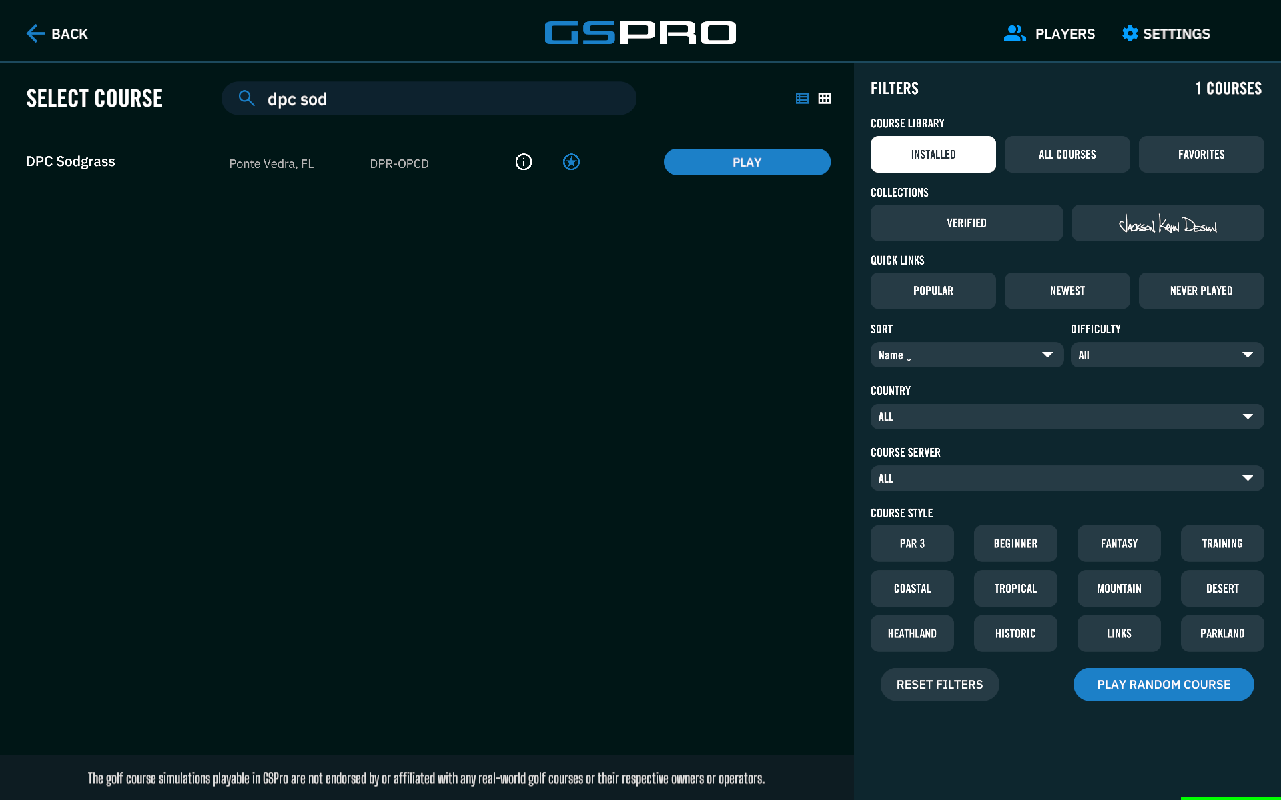

1. Launch GSPro
2. From the welcome screen, select **Local Match**
3. Search for the course listed for this week’s challenge
4. Click **Play Now**

### **Step 2 — Add Players (this is the key part)**

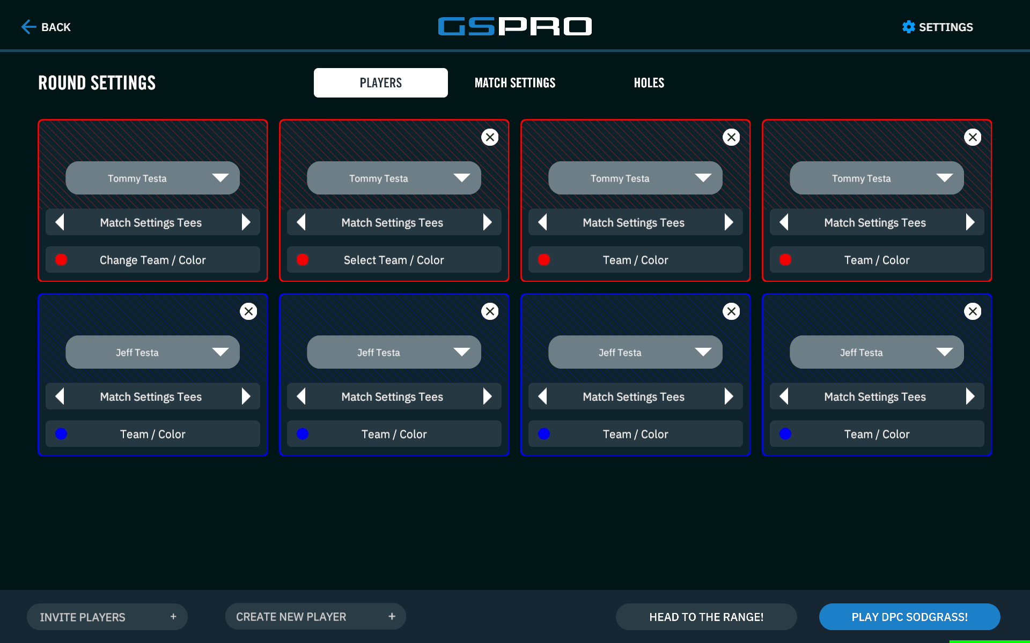

You’re going to add **yourself four times**.

1. Add your player
2. Add the same player again
3. Add the same player again
4. Add the same player again

You should now see your name listed **four times**.

1. Assign all four to the **same team color**

If two people are playing together:  
 • Player 1 adds themselves four times and assigns one team color  
 • Player 2 adds themselves four times and assigns a different team color

GSPro supports up to 8 total players, so two people can do this together.

### **Step 3 — Match Settings**

Open **Match Settings** and set the following:

**Essential Settings** • Format: **Scramble** • Pin Placement: **the pin designated for this challenge** • Mulligans: **OFF** • Tee Box: **the tee designated for this challenge** • Putting: **Pick Your Putt**

**Course Setup** • Green firmness: Normal (unless noted otherwise)  
 • Fairway firmness: Normal  
 • Elevation: Course  
 • Stimp: 11  
 • Wind: No wind (unless noted otherwise)

**Holes** • Deselect all holes  
 • Select **only** the hole for the challenge

Click **Play**.

### **Step 4 — Take Your Shots**

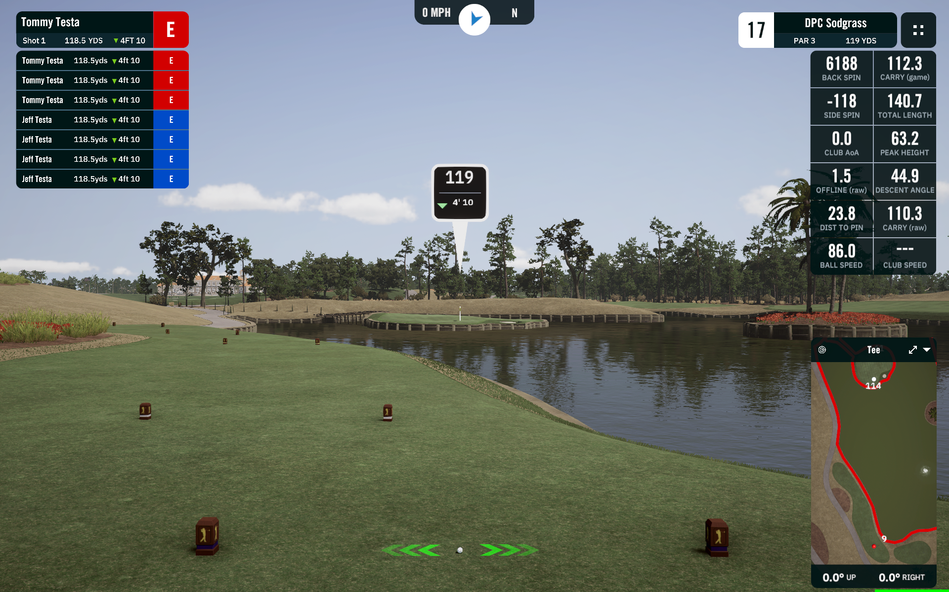

You’ll be placed on the tee.

• Hit all **four shots**• If a shot goes into water or a hazard, choose **Drop Zone** so you can finish the sequence

GSPro will then show the **Pick Your Shot** screen.

### **Step 5 — Use the Pick Your Shot Screen (this matters)**

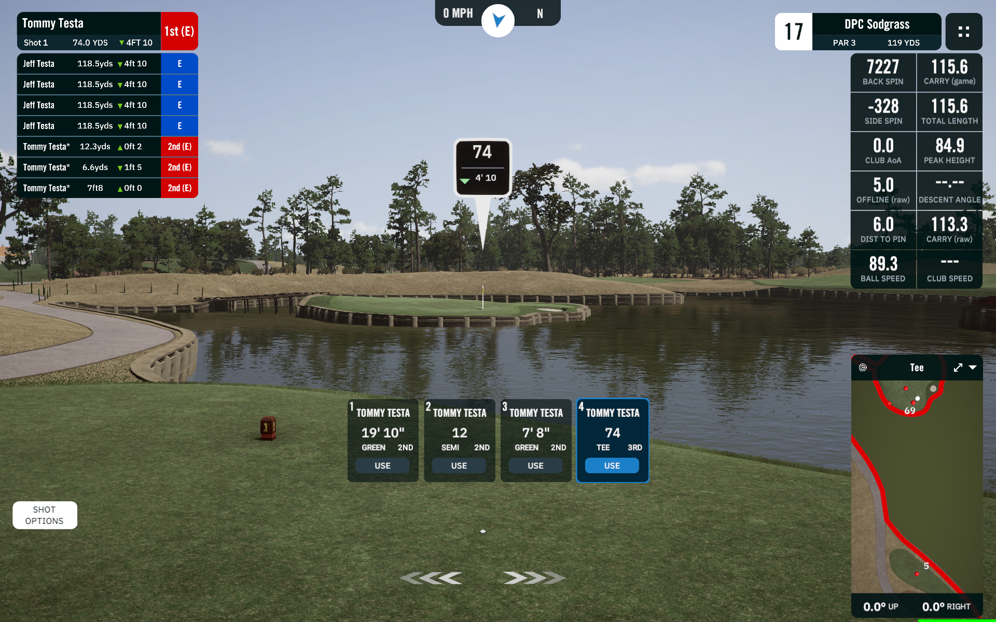

This screen is your **distance summary**.

It shows:  
 • each shot  
 • how far each shot finished from the pin  
 • which one is closest

1. Use this screen to see which shot is closest
2. Enter that distance into the Portal
3. **Take a picture of this screen** with your phone  
    • make sure the player name and distances are visible  
    • make sure the Windows date/time (bottom right of the screen) is visible

Upload that picture in the Portal with your submission.

### **Step 6 — Finish and Re-Up (Optional)**

After all shots are taken, you’ll be on the green.

• Pick any putt to finish (this doesn’t matter for the challenge)  
• When the scorecard appears, tap **Play Again**• You’ll be taken right back to the tee to do another set of four shots